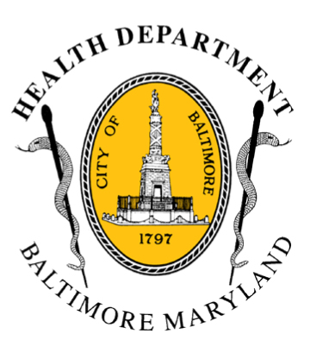
Media Contacts:
BCHD PRESS RELEASE
Baltimore City Health Department
1001 E. Fayette Street • Baltimore, Maryland 21202
Stephanie Rawlings-Blake, Mayor
Leana Wen, M.D., Commissioner of Health

Michael Schwartzberg, PIO - O: (443) 984-2623 C: (443) 462-7939 E: michael.schwartzberg@baltimorecity.gov
Jennifer Fuson, Communications Specialist - O: (410) 545-0823 E: Jen.Fuson@baltimorecity.gov
Health Commissioner’s Statement On Safe Streets East - McElderry Park
BALTIMORE, MD (July 14, 2015) - The Baltimore City Health Department stands united with the Police Department and with our city, state and federal partners in reducing violence and promoting safety in Baltimore.

Operations of the Safe Streets East site in the McElderry Park community have been indefinitely suspended pending further investigation. Safe Streets has a zero-tolerance policy for felony arrests; therefore, the two Safe Street employees allegedly involved have been terminated.

The Health Department works hard every day to protect the health and well-being of residents in our city.

One of our programs is Safe Streets, which has operated in Baltimore since 2007. Safe Streets is an evidence-based approach to stopping crime, where violence interrupters work on the streets to prevent violence from happening.

The staff at Safe Streets sites are employees of community-based organizations, which operate in the communities that they serve. In this case, Living Classrooms operates the site at McElderry Park.

Last year, Safe Streets workers mediated 880 conflicts in Baltimore, more than 80% of which were deemed to be likely or very likely to result in gun violence. Three of the four sites have gone over a year without a fatal shooting.

Safe Streets works because the employees are often ex-offenders who have credibility in the neighborhoods they serve. We also believe in giving opportunities to those who have been incarcerated.

This incident is a reflection on the individuals involved, and should not in any way take away from the great successes of Safe Streets and the role the program has played in preventing and reducing violence. Criminal behavior will not be tolerated. It is a discredit to Safe Streets, to the Health Department, and to the City of Baltimore.

We stand united with the Police Department and our partners in reducing violence in Baltimore and making our city safe and healthy.

###

